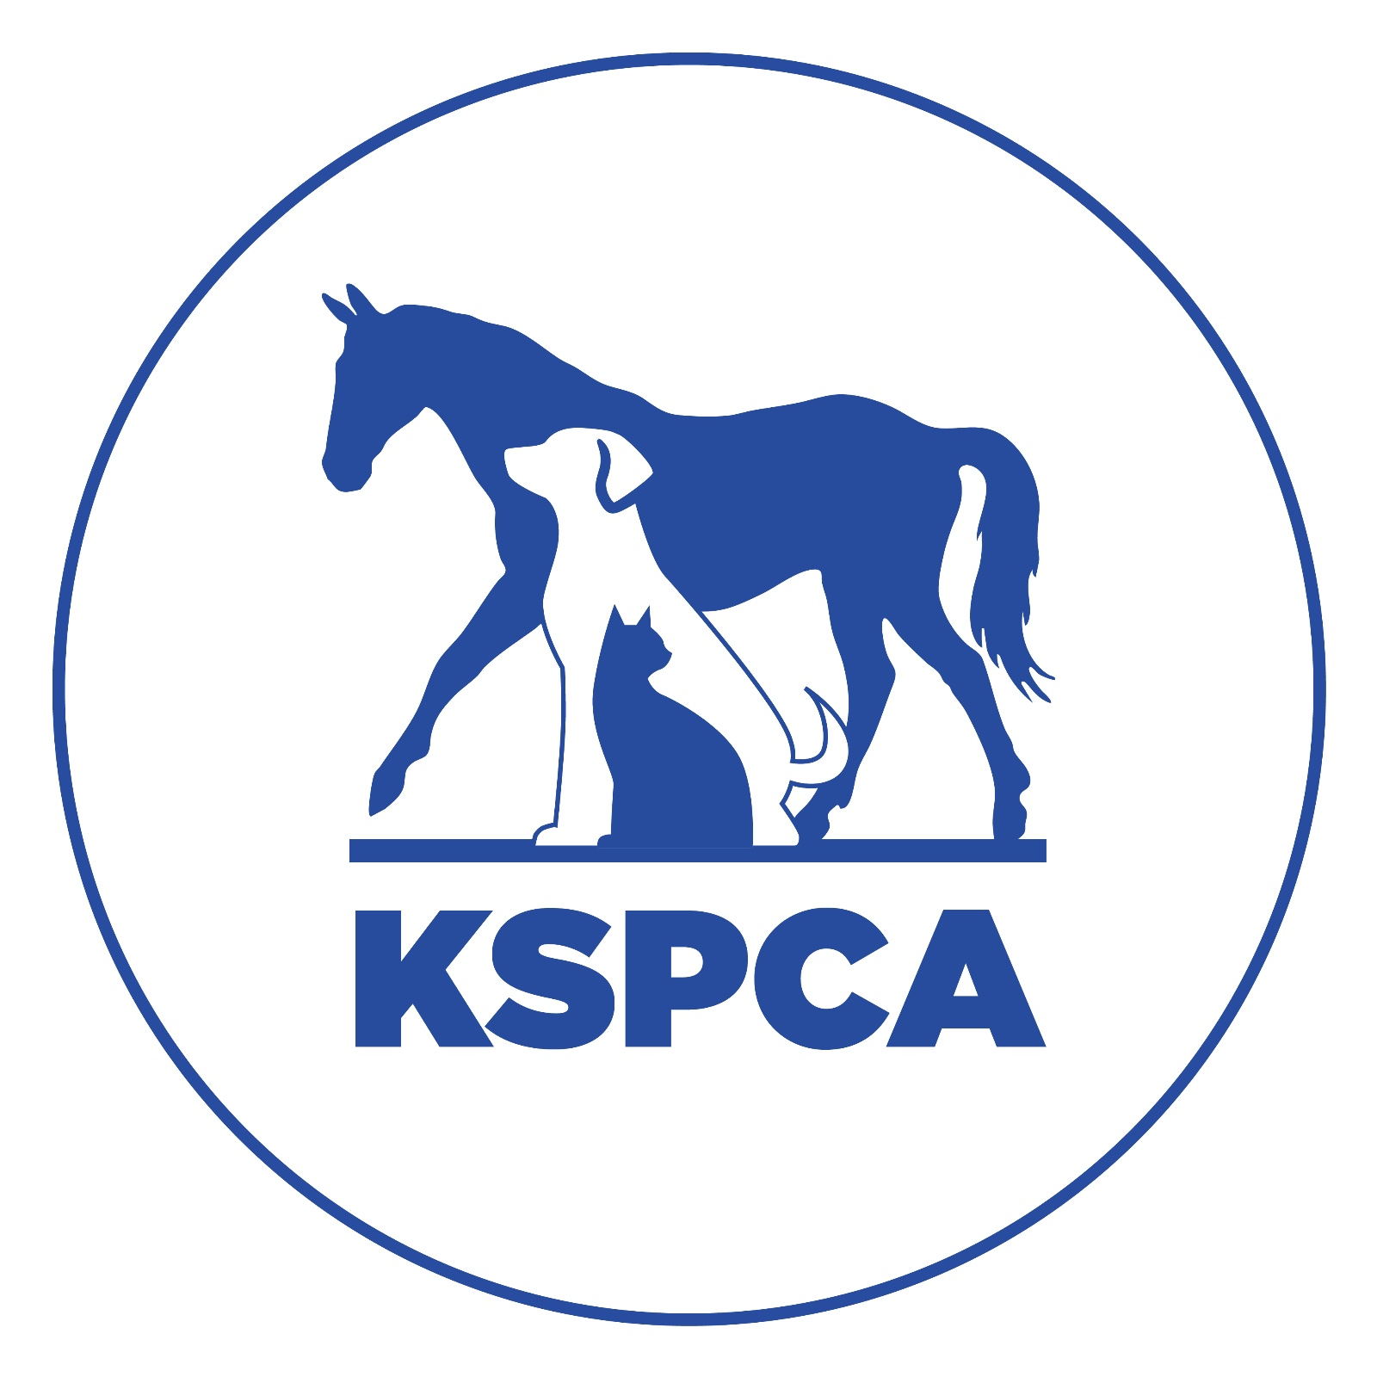

VOLUNTEER GUIDELINES
The Kenya Society for the Protection and Care of Animals can work because of the support of volunteers. Volunteers help us in many ways; from caring for the animals directly, supporting KSPCA projects in the community or fundraising at events.
This guidance is intended to help volunteers and staff have a happy experience with KSPCA.

Volunteering – what it is and how to get involved.
Volunteering is when you offer your time for free to help KSPCA. People volunteer for different reasons, such as love of animals and work experience.
We normally only accept volunteers over the age of 16 as you may have to work unsupervised in a hazardous environment. Younger people may be able to volunteer at the discretion of KSPCA but they will need to be accompanied by a responsible adult. Volunteers will need to sign a waiver form to confirm they accept the risks associated with working with animals.
Volunteers will need to understand and respect the shelter protocols, signage, and instructions from staff.
We would like to request volunteers to be clear about when they are available and be reliable with attendance or to let us know if they can’t make it. This helps us to manage.
If you would like to volunteer, you are welcome to get in touch at info@kspca.or.ke some information about yourself.
We have limited space for volunteers, so please bear with us.

Volunteering at the shelter
Volunteering at the shelter take many forms. Special skills are much appreciated and will be put to good use! We particularly appreciate volunteers experienced in animal behaviour and care. General volunteers can be assigned a range of duties that often include manual dirty work, such as cleaning kennels.
Volunteers should come ready to get dirty! Please also come with a packed lunch or suitable snacks as we aren’t able to provide them at the shelter.

Other kinds of volunteering
We will agree with you about other kinds of volunteering, whether one-off support or on-going. You don’t normally need to sign a waiver if not volunteering in the shelter.
Find us at www.kspca.co.ke , on Facebook, Instagram or on 0709 007 500 and info@kspca.or.ke.

Volunteer information form
Please complete this form if you would like to volunteer at KSPCA.
Name
Contact number (for calls or WhatsApp)

Email
What kind of volunteering are you interested in?

When and for how long are you available?

Have you worked with animals or had animals before?

As KSPCA we have values and policies. Are you able to commit respecting KSPCA values and following instructions of staff for your safety and that of the animals?

Signed
If under the age of 18 this should be signed by parent or guardian

Office use

Activity agreed ………………………………………. Supervisor assigned ………………………………

WAIVER AND RELEASE
I understand that the voluntary services I shall provide at the Kenya Society for the Protection of Animals (“KSPCA”), may involve proximity with unpredictable animals.
I agree that I am entering KSPCA premises and volunteering at KSPCA, at my own risk and of my own volition and I acknowledge and accept that I am aware of all the risks associated with the voluntary services to be provided by me or resulting from my interaction with the various animals or from my being on the KSPCA premises (“my Involvement”).
In view of the above I hereby release KSPCA, its employees, agents, affiliates, officers, other volunteers, contractors, workmen and any owners or operators of KSPCA from any liability for all claims and actions that may accrue from my Involvement. I agree and accept that KSPCA, its employees, agents, affiliates and its officers shall not be liable for any death, injury, delay, loss, damage, nor for any amounts, claims, expenses, losses, liabilities, rights, benefits or entitlements (whether known or unknown) whether under statute, common law or in equity of whatsoever nature and in particular all or any claims rights or applications of whatsoever nature, including any rights arising from any known or unknown (whether within or beyond the contemplation of one or both of us) express or implied breaches of duties owed by the KSPCA to me or my property howsoever arising from, without limitation to my Involvement or from any act or omission of any person (or their sub-contractors, agents or employees whether acting within the scope of their contractual obligations, agency or employments or not) with whom I engage as part of my Involvement or from any attack or injury by any animal or person whether or not such death, injury, delay, loss or damage occurs on the premises owned, occupied or managed by KSPCA.
This waiver is entered into on my behalf and on behalf of any minors accompanying me, and is binding on my assigns, heirs and legal representatives.
I understand that by signing this waiver and release I will not have any right to recover from KSPCA any loss, damage or injury suffered by me or caused to my property.
If any portion of this waiver and release is unenforceable, such portion shall be struck out provided that the remaining portion shall remain in full force and effect.
This waiver shall be governed by Kenyan law.
In WITNESS WHEREOF this Deed has been executed on (date)
Name*
Signature*

ID/PPT number*
Contact phone number, email: *

In the presence of*

*Must be supplied.

